

aUTOMATIC gREEN HOUSE SYSTEM

TPJ452 Interim Report



Course: TPJ452

Instructor: Gal Messinger

Group Number: 2

Group Members: Huang Zheng, Yu Chen

Member’s STD#: 025-775-115, 046-158-143

Date: November 9, 2016

Contents

1. Introduction 1

2. What we archived: 2

• Hardware Part: 2

• Soil Moisture Monitoring Sytem: 2

• Light Control Cover 3

• Air Temperature Monitoring System: 3

• PCB Designing/Soldering: 4

• Software Part: 5

• System Monitor 5

• Remote Control 6

• Emergency Only 6

3. What we will do next 6

# Introduction

From the date of we decide the topic to today, we spent a lot of time on researching, designing, testing, and degugbing for our Automic Green House project. For now, we have almost done the project. In the hardware part we have done bread board circuit design and test, and PCB design and soldering, and they all work well. In the software part, we developed an Android application to comminicate with Arduino through the Bluetooth in our project. Finally, we will combine hardware and software together to finish our project in next couple weeks.

# What we archived:

## Hardware Part:

We did a lot of research on the hardware, such as the circuit connection with the sensors and the Arduino board, and then made connections with components to test them. Therefore, we divided project into 3 parts, which include soil moisture monitoring system, light control cover, and air temperature monitoring system.

## Soil Moisture Monitoring Sytem:

## In this part we are using Soil Moisture sensor to detect moisture of soil, and using the Red, Yellow, and Green LEDs to show the status of soil. We set the maximum value is 800 and minimum value is 500. So when the value of sensor is equal and higher than 800 the green led will be ON, that means the soil is wet and we don’t need to warting, but when the value is between 800 and 500 ,and yellow led will be ON, that means the soil is a little bitdry. Once the value is lower than 500, the red led will be ON, which means the soil is very dry, this will triggle the irrigation system, and water pump start the put water on the plant.

|  |  |  |  |
| --- | --- | --- | --- |
| **Sensor Value** | **LED Color** | **Soil Status** | **Water Pump Status** |
| =>800 | Green | Wet | OFF |
| >=500 &&<800 | Yellow | a little bit Dry | OFF |
| >500 | Red | Very Dry | ON |

## Light Control Cover

## The second part is the light control cover. We installed 2 light sensors and 4 micro servos on the board, when both light sensors detect light and the value is higher than 500, it will triger the micro servos to open the cover. This is the easiest part in our project.

|  |  |  |
| --- | --- | --- |
| **Sensor Value** | | **Cover Status** |
| Light Sensor 1 | <500 | Cover is CLOSE |
| Light Sensor 2 |
| Light Sensor 1 | >500 | Cover is OPEN |
| Light Sensor 2 |

## Air Temperature Monitoring System:

## The third pard is the air temperture monitoring system. We can set the temperature into the system (curenttly not avaiable, system default temperture is 23 °C), when temperature is higher than 23 °C, then it will triger the Fan to cool down the air temperature. But when temperature is lower than 16 °C, the heater will trigger. The system will do nothing between 16 °C to 23 °C.

|  |  |
| --- | --- |
| **Air Temperature** | **Fuction** |
| > 23 °C | Fan (cooler) |
| >16 °C && <23 °C | Nothing Happen |
| <16 °C | Heater |

## PCB Designing/Soldering:

We have done designing and soldering the PCB.

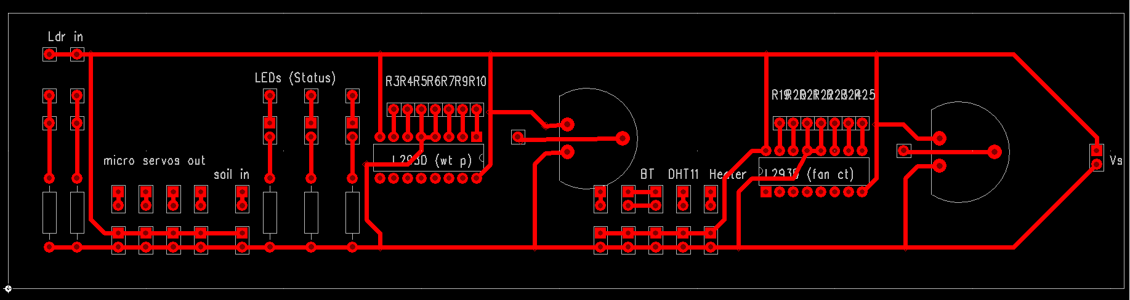

## Software Part:

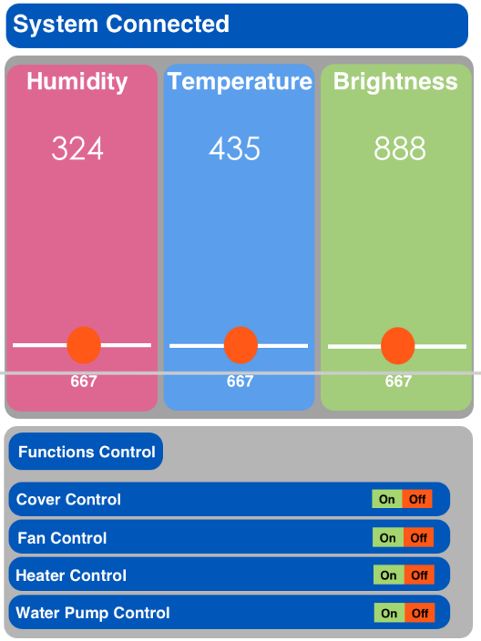

Figure 1: GUI Layout

## System Monitor:

When the application start, user should choose the Arduino board to connect. Once they are paired, the application should read messages through Bluetooth channel. Getting the value of light sensor, temperature sensor, and soil moisture sensor. Show them on the screen.

## Remote Control

There are three progress bar indicate current condition values of all sensors. By dragging the bar, it is very easy to adjust the condition values. Arduino board will respond to the changes and adapt to new values.

## Emergency Only

For emergency use only, there are four switch to turn on and off fan, heater, water pump, and cover.

# What we will do next

* In the next couple weeks we will:
* Add the heater into our project
* Finish testing the Bluetooth and install it into our Arduino Board
* Test the Android app and let app to monitor and control the system
* Debugging whole project
* Packing